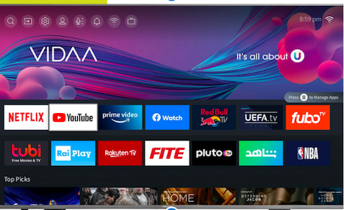
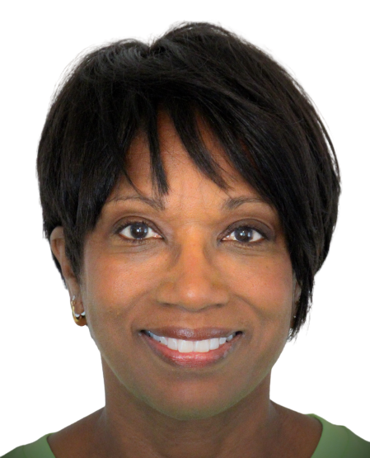
PRESS RELEASE
FROM PRIME UNIVERSAL NETWORK

For Immediate Release
Contact: Prime Universal Network Office
rodney@primeuniversalnetwok.com or 317-383-6513

Prime Universal Network, a husband and wife-owned, all-positive, TV network signs with Hisense, the third largest TV manufacturer in the world.

Avon, IN, September 1, 2022 - Prime Universal Network, a division of Prime Local TV Network, Inc., has signed a distribution agreement with International manufacturer, Hisense, and their content platform VIDAA. They will place Prime Universal Network’s positive content TV App onto 140 million currently purchased televisions and an additional 30+ million new televisions annually.

Prime Universal Network’s content platform called - ‘The Positive People Platform,’ came into existence in 2018 after Rodney and Holly Harris began their search for positive and uplifting human interest stories, being showcased, on a consistent basis.

The Positive People Platform offers only positive content produced by the couple and other content producers, with a variety of short stories, sports, documentaries and events. Their platform is showcasing the positive people experiences of everyday people.

Mission - To change the negative narrative and misunderstanding that positive content means boring. Positive can be and is exciting, interesting and informative. Our world already has enough negative content!

History - How did they get started in media? Born in Akron/Canton Ohio areas, they began covering their hometown hero LeBron James, when he played with both Cleveland/Miami NBA teams. They also covered most of his NBA Finals games.

Contact Information: Website: www.primeunivesalnetwork.com
Rodney Harris - 317-556-6061 Linkedin Holly A Harris Linkedin

###

